FACULTY EVALUATION
Programme Name: Social Entrepreneurship Program (SEP)- START Alumni MASTERCLASS (16th February 2026 - 20th February 2026)
Session: Social impact measures and planning
Faculty Name: Dr. Cathy Mbidde
No. of Respondents: 7
No. of Participants: 10
Evaluation Parameter | (%) Individual Score | (%) Programme Average
Punctuality (Commencement and Completion of Sessions) | 80 | 80
How well do you understand the core concepts presented? | 77 | 80
Rate your confidence in applying the new skills learnt | 71 | 74
Degree of Faculty preparedness for the sessions | 87 | 92
Content and methodology of the program | 83 | 87
Quality of class and group discussions | 69 | 74
The information presented in the course is relevant to my work (ministry) | 86 | 88
Average scores | 79 | 82

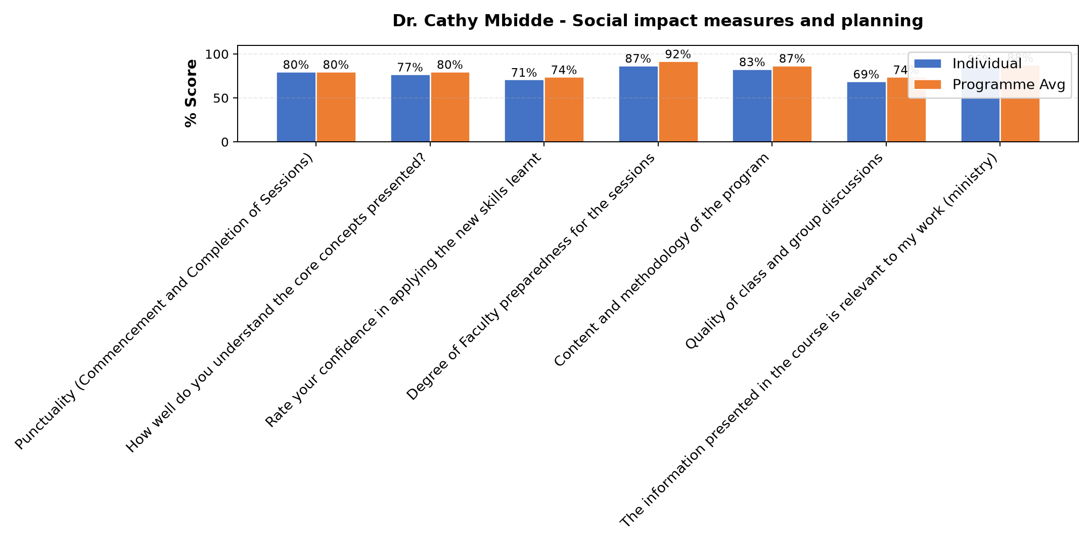

Comments & Feedback
- • Time limitation
- • Scarcity of resources
- • Distance from the project site
- • Lack of enough resources
- • ministry at hand. time clashes.
- • financial constraint
SUBMITTED THROUGH:
SBS Evaluation Automation System

